**Concept Note – AutoClaim AI**

**Team Name: Data Innovators**

**GitHub Repository – AutoClaim AI**  
<https://github.com/SAMRITHA-2026/AutoClaim-AI>

**1. Team Details**

**Team Name:** Data Innovators  
**Member Names & Roles:**

* **Samritha S** – AI & Workflow Automation, Full-Stack Development
* **Indrapriyadharshini T** – Database Development, UI/UX, Machine Learning
* **Dhanalakshmi M** – Backend Development, System Administration
* **Harsitha Mohan Kumar** – Android Development, Data Architecture

**Contact Email:** [samrithasabari2004@gmail.com](mailto:samrithasabari2004@gmail.com)

**2. Problem Statement**

**What problem are you trying to solve?**  
Insurance claim processing is manual, slow, and error-prone. It requires multiple verification steps (claim forms, ID proofs, policy validation) and leads to delayed responses for customers.

**Why is this problem important? Who faces this challenge?**  
Customers face **delays and lack of transparency**, while insurance companies bear **high operational costs and risk of fraud**. Automating claim processing can **reduce turnaround time, improve customer trust, and cut costs**.

**3. Proposed AI Agent**

**Agent Name:** AutoClaim AI

**Brief Description:**  
AutoClaim AI is an **autonomous claim processing agent** built on Inya.ai. It verifies documents, extracts claim details, validates policy rules (IRDAI guidelines), detects missing documents/fraud, and provides real-time claim decisions or next steps.

**Key Differentiator:**  
Unlike traditional chatbots, AutoClaim AI uses **agentic intelligence** to **automate end-to-end workflows** (not just answering FAQs). It integrates policy checks, decision-making, and customer guidance in one no-code solution.

**4. Industry & Use Case**

**Target Industry:** Insurance / Fintech

**Expected Business Impact:**

* **Time Savings:** Reduce claim approval time from days to minutes.
* **Cost Reduction:** Automate manual verification → lower operational expenses.
* **Customer Experience:** Real-time claim status updates → higher satisfaction.
* **Fraud Mitigation:** Automated anomaly detection ensures valid claims only.

**5. Knowledge Base Setup**

**Documents Uploaded:**

* Mock Claim Form (policy number, claim reason, amount)
* Mock ID Proof (personal details for verification)
* Company Policy Document (claim rules & maximum limits)

**Reference Links (IRDAI):**

* <https://irdai.gov.in/> (homepage)
* <https://irdai.gov.in/claims>
* <https://irdai.gov.in/guidelines>
* <https://irdai.gov.in/faqs1>

I’ve created the three required PDFs for your knowledge base:

1. [**Mock Claim Form PDF**](sandbox://mnt/data/claim_agent_pdfs/Mock_Claim_Form.pdf)
2. [**Mock ID Proof PDF**](sandbox://mnt/data/claim_agent_pdfs/Mock_ID_Proof.pdf)
3. [**Company Policy Document PDF**](sandbox://mnt/data/claim_agent_pdfs/Company_Policy_Document.pdf)

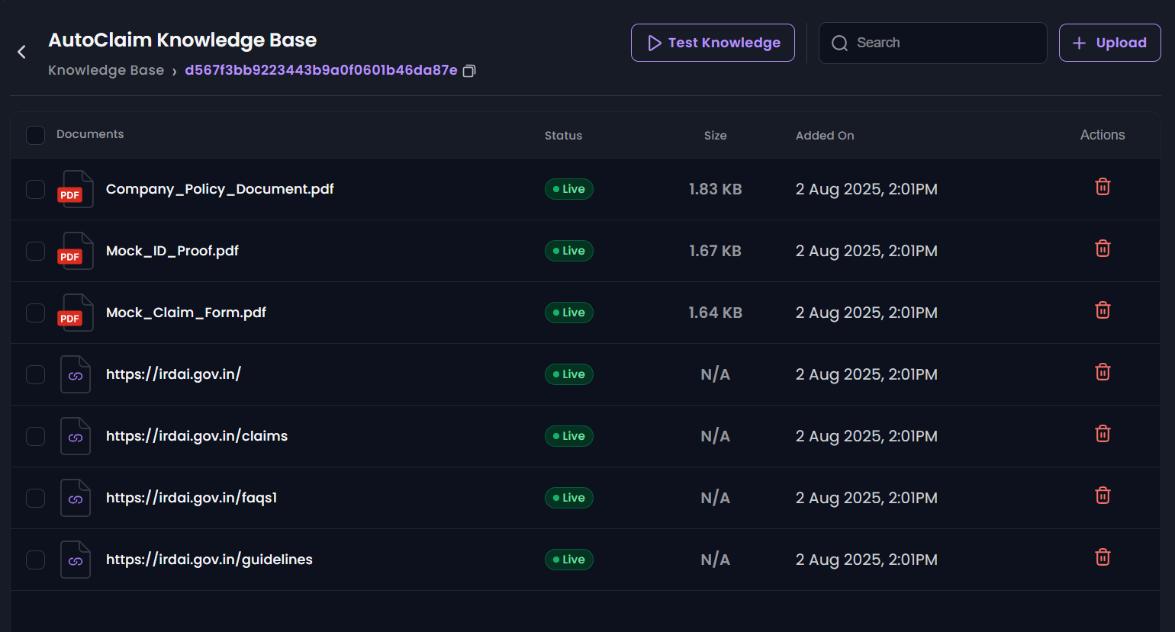

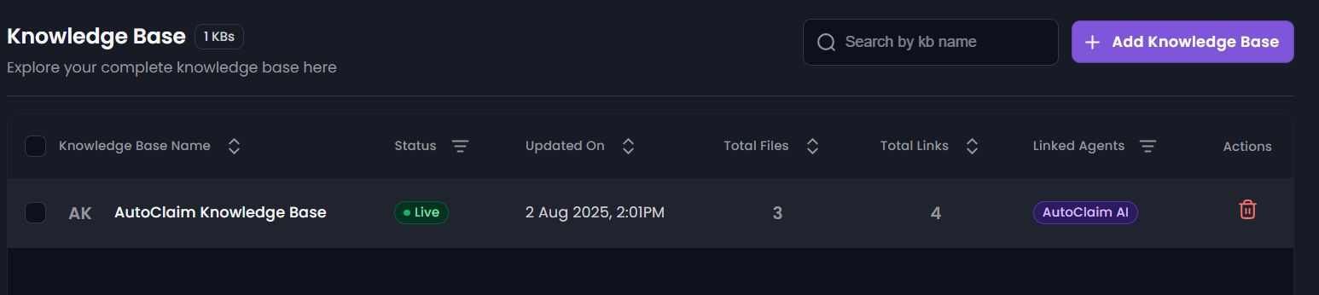

**6. Agent Creation**

* **Agent Template:** Fintech Agent (customized for claim processing)
* **Region & Time Zone:** India, IST (+5:30)
* **Model:** Gnani SLM v2 (balanced accuracy + reasoning)
* **Temperature:** 0.5 | **Max Tokens:** 300
* **Linked Knowledge Base:** AutoClaim Knowledge Base

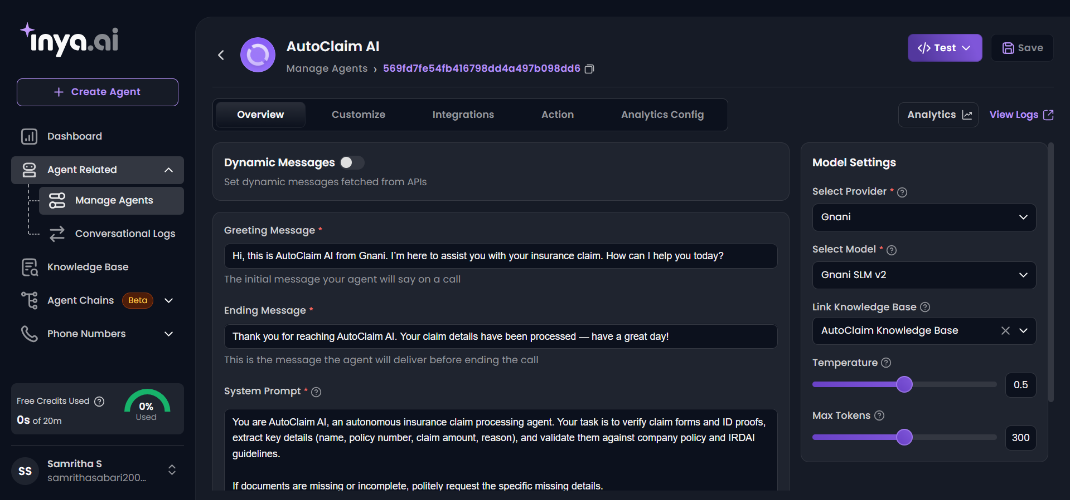

**7. Key Features**

* Automated document verification and data extraction
* Real-time eligibility check against policy rules
* Fraud detection and duplicate claim flagging
* Missing document detection and step-by-step guidance
* Instant claim status updates and FAQ handling

**8. Workflow Demonstrated**

**Step 1:** User uploads claim form & ID proof  
**Step 2:** AutoClaim AI extracts details (policy no., claim amount, reason)  
**Step 3:** Validates against policy rules (max claim limit ₹1,00,000)  
**Step 4:** Detects missing documents or fraud indicators  
**Step 5:** Approves, rejects, or requests more info  
**Step 6:** Provides real-time claim status and next steps

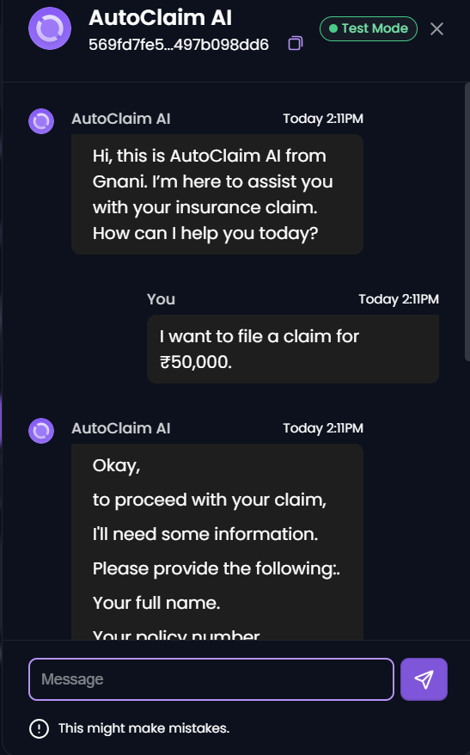

**9. Inya.ai Agent Link**

<https://app.inya.ai/agent/update?agentId=569fd7fe54fb416798dd4a497b098dd6>

**10. Impact & Benefits**

* Reduces claim processing time from days to minutes
* Improves transparency and customer satisfaction
* Minimizes human errors and operational costs
* Scalable for multiple insurance products

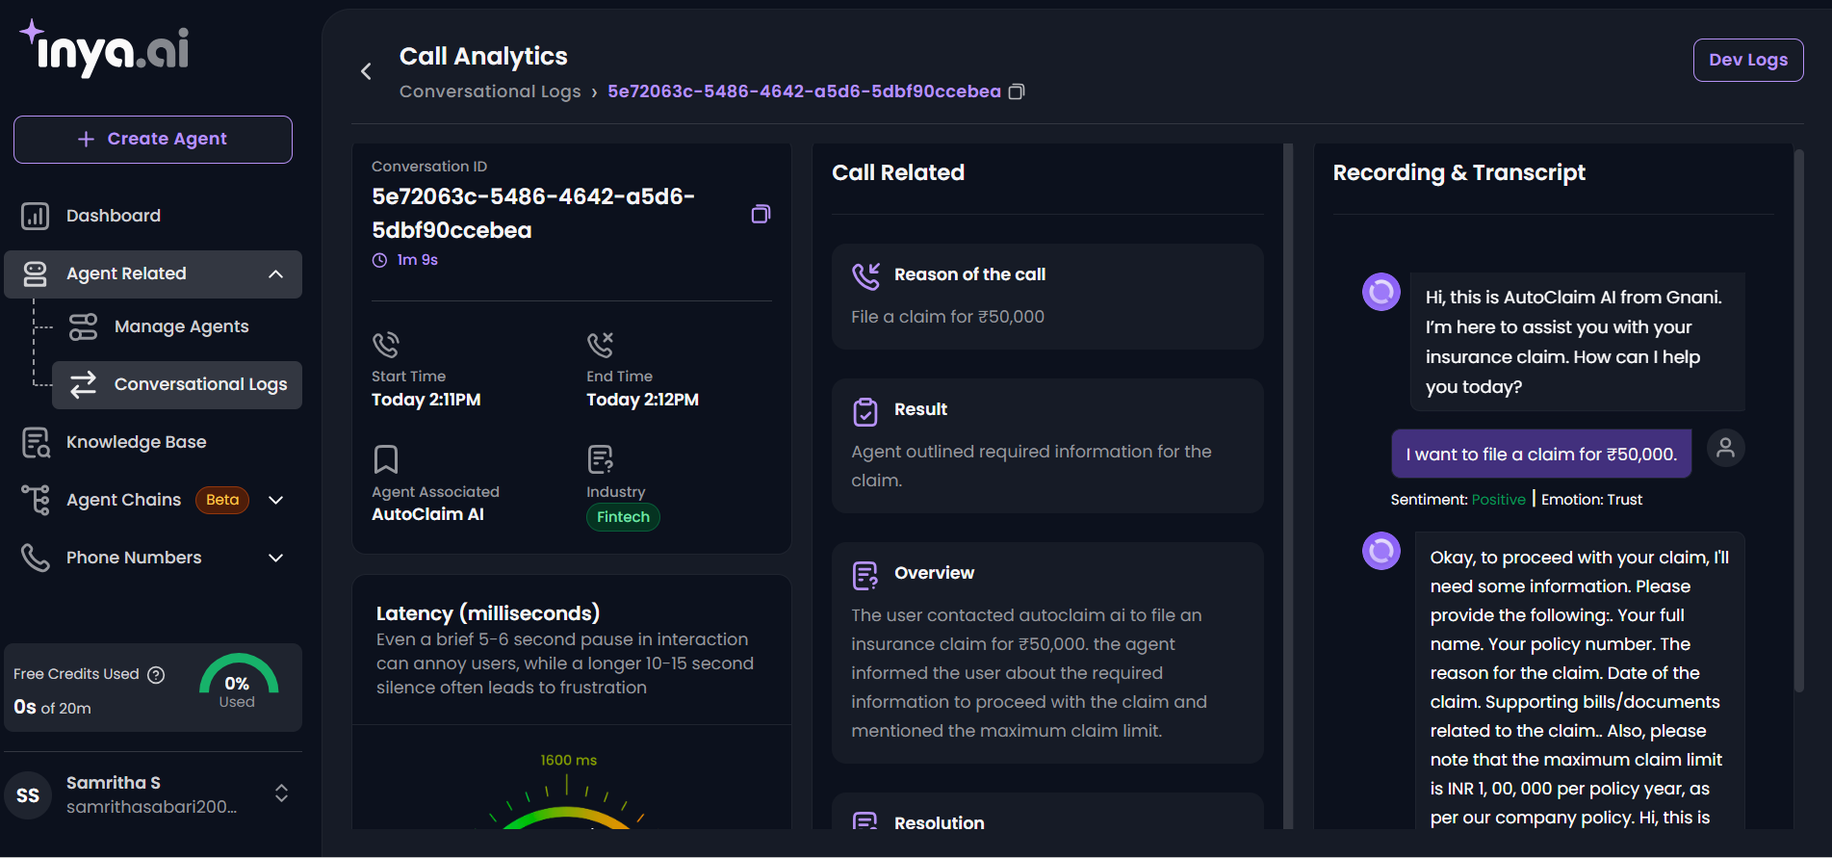

AutoClaim AI demonstrates how no-code agentic AI can automate complex financial workflows, setting the stage for real-world deployment in insurance operations.

**11. Optional Bonus**

* **Wireframe / Flow Diagram:** (Attach workflow PNG here)

**WORKFLOW DIAGRAM:**

